Supplementary material

Supplementary Table 1. Correlation between ZWINT expression and clinicopathological characteristics of PCa.
Characteristic |  |  | Low expression of ZWINT | High expression of ZWINT | p value
n |  |  | 249 | 250
T stage, n (%) |  |  | Reference |  | 0.002*
 |  | T2 | 111 (22.6%) | 78 (15.9%)
 |  | T3 | 132 (26.8%) | 160 (32.5%)
 |  | T4 | 2 (0.4%) | 9 (1.8%)
N stage, n (%) |  |  | Reference |  | 0.038*
 |  | N0 | 175 (41.1%) | 172 (40.4%)
 |  | N1 | 29 (6.8%) | 50 (11.7%)
M stage, n (%) |  |  | Reference |  | 1.000
 |  | M0 | 225 (49.1%) | 230 (50.2%)
 |  | M1 | 1 (0.2%) | 2 (0.4%)
Age, n (%) |  |  | Reference |  | 0.303
 |  | ≤60 | 118 (23.6%) | 106 (21.2%)
 |  | >60 | 131 (26.3%) | 144 (28.9%)
PSA (ng/mL), n (%) |  |  | Reference |  | 0.112
 |  | <4 | 212 (48%) | 203 (45.9%)
 |  | ≥4 | 9 (2%) | 18 (4.1%)
Gleason score, n (%) |  |  | Reference |  | <0.001*
 | 6 |  | 28 (5.6%) | 18 (3.6%)
 | 7 |  | 142 (28.5%) | 105 (21%)
 | 8 |  | 32 (6.4%) | 32 (6.4%)
 | 9 |  | 46 (9.2%) | 92 (18.4%)
 | 10 |  | 1 (0.2%) | 3 (0.6%)
ZWINT: ZW10 Interactor; PSA: Prostate-specific antigen; * p < 0.05.

Supplementary Table 2. Univariate COX regression analysis of PCa prognosis.
Characteristics |  | Progress free interval |  |  | Disease free survival
 |  | Total (n) | Hazard ratio (95% CI) | p value | Total (n) | Hazard ratio (95% CI) | p value
T stage |  | 492 |  |  | 471
 | T2 | 189 | Reference |  | 184 | Reference
 | T3 & T4 | 303 | 3.79 (2.14–6.69) | <0.001* | 287 | 3.66 (2.06–6.50) | <0.001*
N stage |  | 426 |  |  | 409
 | N0 | 347 | Reference |  | 334 | Reference
 | N1 | 79 | 1.95 (1.20–3.15) | 0.007* | 75 | 1.93 (1.19–3.14) | 0.008*
Age |  | 499 |  |  | 477
 | ≤60 | 224 | Reference |  | 214 | Reference
 | >60 | 275 | 1.30 (0.86–1.96) | 0.208 | 263 | 0.65 (0.43–1.01) | 0.053
PSA |  | 442
 | ≤4 | 415 | Reference |  | 395 | Reference
 | >4 | 27 | 4.20 (2.09–8.41) | <0.001* | 26 | 3.44 (1.65–7.14) | <0.001*
ZWINT |  | 499 |  |  | 477
 | Low | 249 | Reference |  | 238 | Reference
 | High | 250 | 1.93 (1.27–2.96) | <0.001* | 239 | 2.01 (0.40–0.95) | 0.027*
Gleason score |  | 499 |  |  | 477
 | 6 & 7 | 293 | Reference |  | 287 | Reference
 | 8 & 9 & 10 | 206 | 4.68 (2.96–7.39) | <0.001* | 190 | 4.36 (2.74–6.94) | <0.001*
ZWINT: ZW10 Interactor; PSA: Prostate-specific antigen; CI: Confidence interval; * p < 0.05.

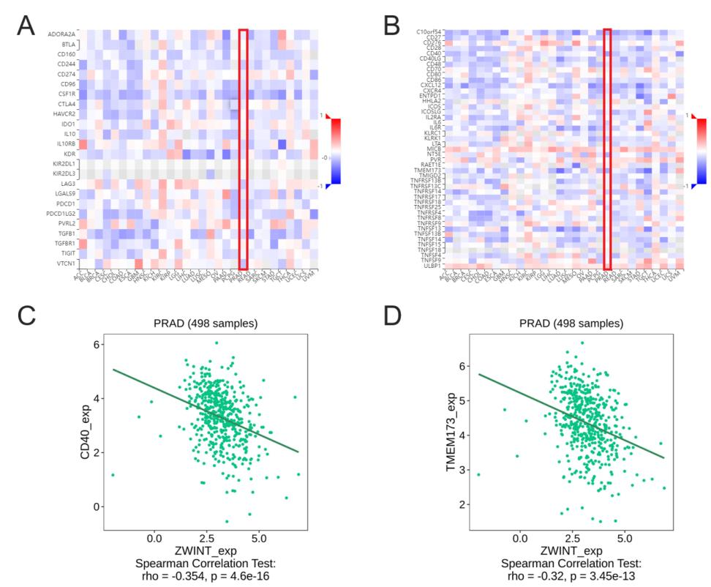
Supplementary Fig. 1. The correlation between ZWINT expression and immune factors. (A): Correlation of ZWINT expression with immunosuppressive factors in PCa and other cancers. (B): Correlation of ZWINT expression with immunostimulatory factors in PCa and other cancers. (C,D): The expression of ZWINT was negatively correlated with the expression of immunostimulatory factors CD40 and TMEM173. CD40: Cluster of differentiation 40; TMEM173: Transmembrane protein 173; PRAD: Prostate adenocarcinoma.

